Lesson 2: Lets get Series(ous) Circuits

- Connect the Circuit Picture with lines for wires using the Schematic Diagram.

Circuit Picture Schematic Diagram
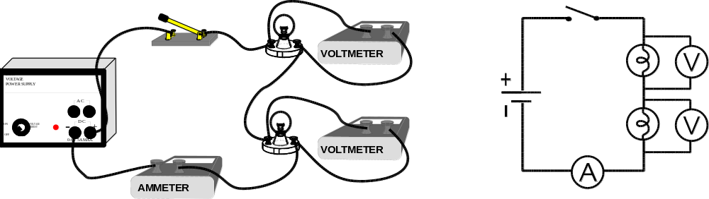
- When two bulbs are connected in series, our model predicts;
a) the ELECTRIC CURRENT through each bulb will be less or slow down

b) the ELECTRIC POTENTIAL (VOLTAGE) across each bulb will be half of what it was with one bulb in the circuit.

- If we ignore the meters, there is/are one different paths for the electrons to get around the circuit? Another way of saying this is “ There is/are one path for the current?”

- In the above series circuit, if one light bulb burns out, our model predicts :
a) the ELECTRIC CURRENT through each bulb will stop flowing

b) the BRIGHTNESS of the remaining bulb will go out

- If we ignore the meters, our model predicts we can control all bulbs by placing the switch anywhere in this type of circuit.

- When bulbs (or anything else) are connected one after the other in a single path, we call it a series circuit.

- a) Label all the points indicated on the schematic diagram on the circuit picture.
b) Assume power supply produces 6 amperes and 12 volts, write the expected readings beside each meter
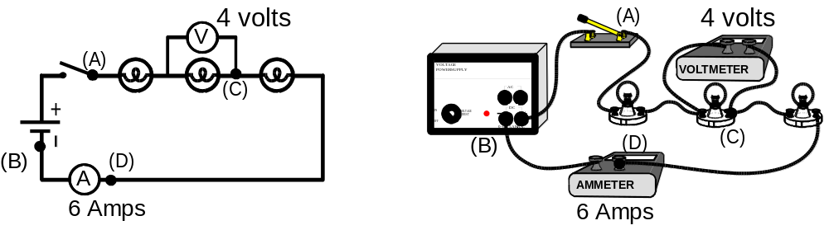

- a) Label all the points indicated on the circuit picture on the schematic diagram.
b) Assume power supply produces 6 amps and 12 volts, write the expected readings beside each meter
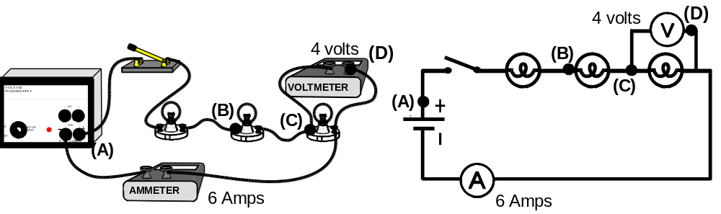

- a) Draw lines to represent conductors on the Circuit Pictures in order to complete the circuits shown the Schematic Diagram.

b) Assume power supply produces 6 amperes and 12 volts, write the expected readings beside each meter
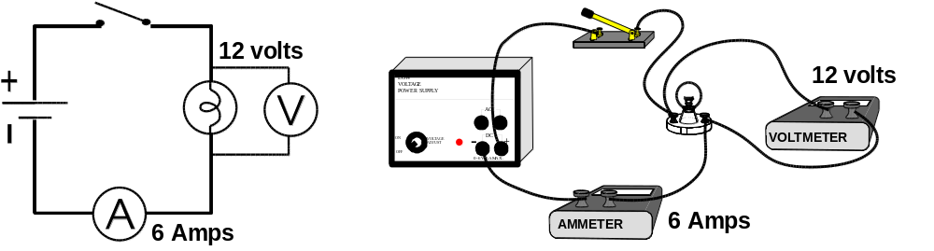

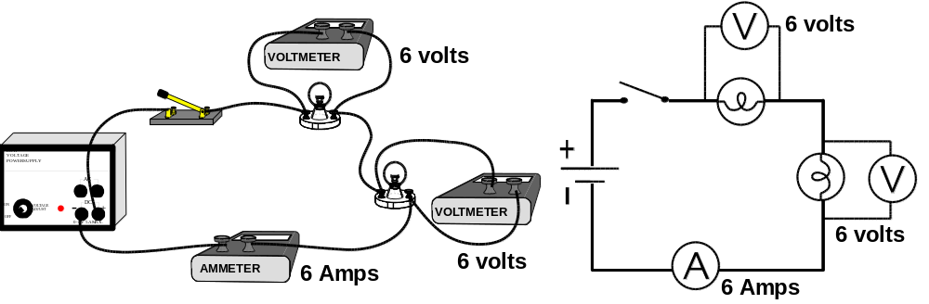

- a) Sometimes its hard to physically place a meter in the same relative position (where it should be) Draw lines to represent conductors on the Circuit Picture in order to complete the circuits shown the Schematic Diagram.
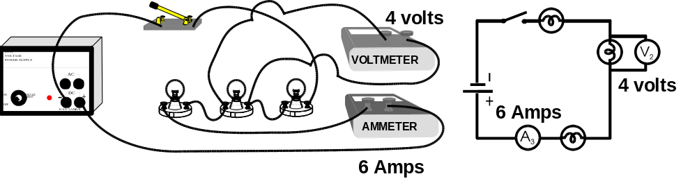
b) Assume power supply produces 6 amperes and 12 volts, write the expected readings beside the each meter

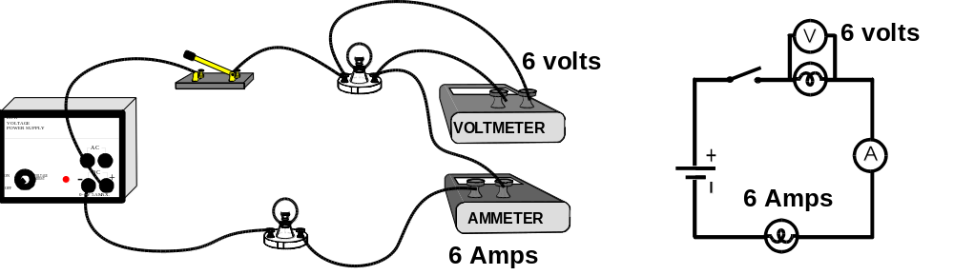

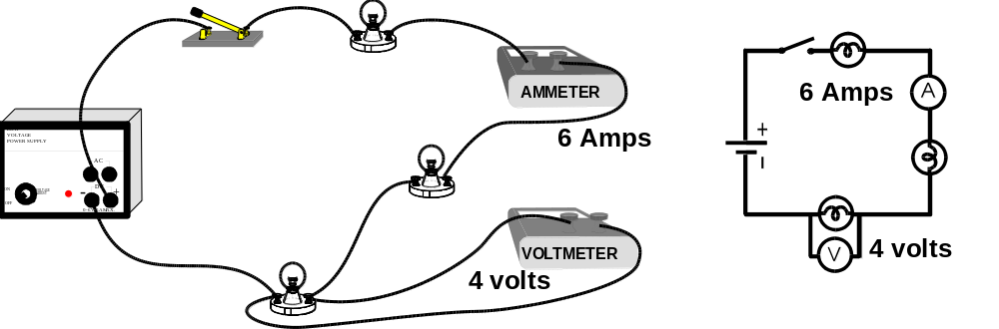

REALITY CHECK - Wiring Real Circuits
Wire the circuits shown.
Record the meter readings and compare bulb brightness.
Note all meters do not have to be connected at once. Connect the meter in one particular position, take the reading, remove it and reconnect it in the next position.

Schematic Diagram | Voltage  (Volts) |  | Current  (Amperes) |  | Bulb  Brightness | If one bulb is turned out:
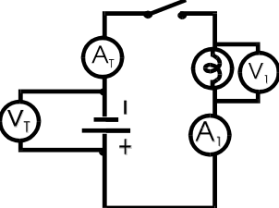 | V_{T} | example  +10 V | A_{T} | 0.67 A | Normal Brightness compared to the other circuits
 | V₁ | -10 V | A₁ | 0.67 A | Normal Brightness compared to the other circuits
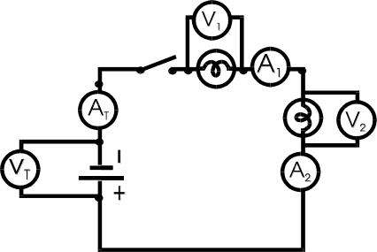 | V_{T} | +10 V | A_{T} | 0.33 A | DIMMER Brightness compared to the Normal | The other bulb GO OUT
 | V₁ | -5 V | A₁ | 0.33 A | DIMMER Brightness compared to the Normal | The other bulb GO OUT
 | V₂ | -5 V | A₂ | 0.33 A | DIMMER Brightness compared to the Normal | The other bulb GO OUT
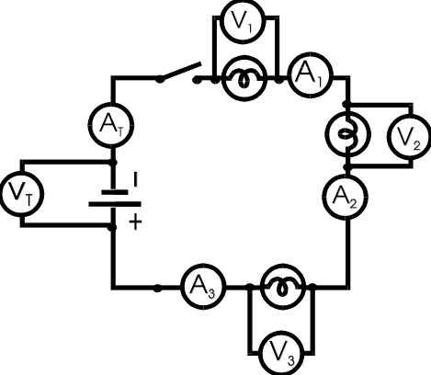 | V_{T} | +10 V | A_{T} | 0.22 A | VERY DIM Brightness compared to the Normal | The other bulbs GO OUT
 | V₁ | -3.3 V | A₁ | 0.22 A | VERY DIM Brightness compared to the Normal | The other bulbs GO OUT
 | V₂ | -3.3 V | A₂ | 0.22 A | VERY DIM Brightness compared to the Normal | The other bulbs GO OUT
 | V₃ | -3.3 V | A₃ | 0.22 A | VERY DIM Brightness compared to the Normal | The other bulbs GO OUT

Use the results from your table to answer the following:

- In any series circuit, what can you say about the amount of current measured anywhere in the circuit?

- In a series circuit containing;
  - ONE bulb, the voltage drop across the bulb is about = the voltage drop across the source

- TWO identical bulbs, the voltage drop across each bulb is about ½ the voltage drop across the source.

- THREE identical bulbs, the voltage drop across each bulb is about 1/3 the voltage drop across the source.

- Look at all three circuits, as more bulbs are connected in series,
[Circle ↑for increase, ↓for decrease, ↔for unchanged, and →0 for goes to zero]
a) the brightness of each bulb ↑↓ ↔ →0
b) the size of the current ↑↓ ↔ →0
c) the number of paths for the current ↑↓ ↔ →0

- In a series circuit, if one light bulb burns out,
a) the current ↑↓ ↔ →0
b) the brightness of the remaining bulbs ↑↓ ↔ →0

Applying What You’ve Learned

- Fuses act like switches which open (turn off current) if a short circuit occurs. Fuses must be connected in series to the rest of the circuit.

- Switches are connected in series to what they control in the circuit.

- Ammeters are connected in series to what they are measuring the current through.

- In order to connect a am meter to a circuit you must break the circuit and insert the meter in series.

- Two students wire a circuit. Unfortunately when the switch is closed, no light bulbs go on. What do you think the problem most likely is? List what you think they should check 1st, 2nd, 3rd , etc. by placing a number beside the following possible problems.
2nd Loose Connections - Check by gently shaking each connection .
3rd Loose Bulb- Check by tightening each bulb.
7th Burnt out Bulb - Check by viewing filament of each bulb or connecting it directly to power
6th Incorrect Wiring - Check relative positions of circuit parts and follow path current would take around the circuit starting at source and returning to it.
5th Incorrect Wiring - Check the Ammeter is connected in series
4th Incorrect Wiring - Check the Voltmeter is connected around the circuit part
1st No Power - Check the indicator light of the power supply to ensure it is turned on or check the battery with a single bulb.
ANSWERS WILL VARY GREATLY. THE INTENT OF THIS QUESTION IS TO HELP STUDENTS DEVELOP THEIR OWN TROUBLESHOOTING HEURISTIC

- A student has used the schematic diagram below to wire the circuit picture shown. Unfortunately when the switch is closed, no light bulbs go on. The light of the power supply indicates that there is power. All connections have been checked and are good. What is wrong?

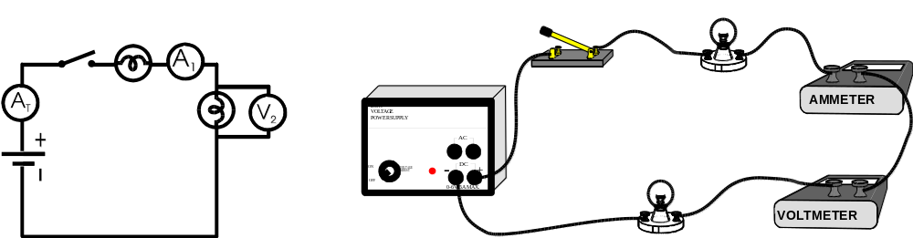
THE VOLTMETER IS CONNECTED IN SERIES. VOLTMETERS HAVE HIGH RESISTANCE (SEE LESSON 5: RESISTANCE - OHM’S LAW PAGE 22). VOLTMETERS DO NOT ALLOW CURRENT TO FLOW THROUGH VERY EASILY.

- Another student has used the Schematic diagram below to wire the circuit picture shown. The voltmeter (V_{T}) at the source reads 12 volts. The reading on a voltmeter placed at (V₂) should be 4 volts.
When the switch is closed, the centre light bulb does not go on and the reading on the meter beside the second light is not what it should be. What is wrong?
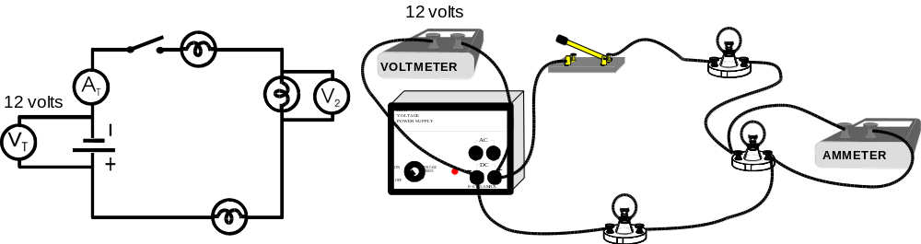
THE METER AROUND THE SECOND BULB IS AN AMMETER INSTEAD OF A VOLTMETER. AMMETERS ACT JUST LIKE WIRES AND ALLOW CURRENT TO FLOW THROUGH VERY EASILY. THIS CAUSES A “SHORT CIRCUIT” AROUND THE SECOND BULB. AMMETERS HAVE VERY LITTLE RESISTANCE (SEE LESSON 5: RESISTANCE - OHM’S LAW PAGE 22)

